Chapter 19, Solution 93

We apply the same formulas derived in the previous problem.

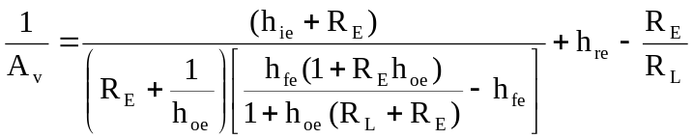

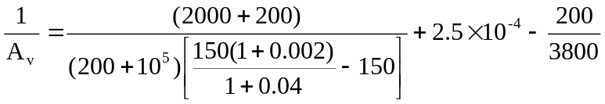
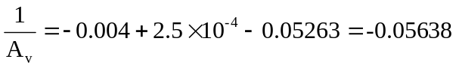

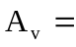–17.74

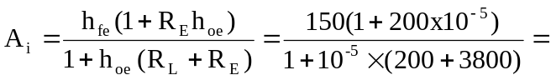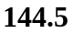

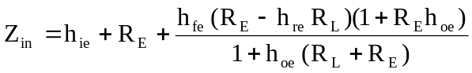

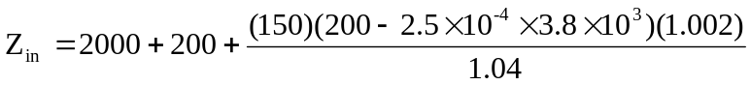
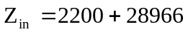
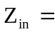31.17 kΩ

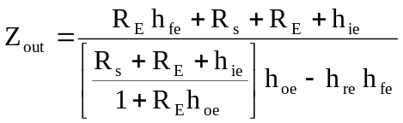

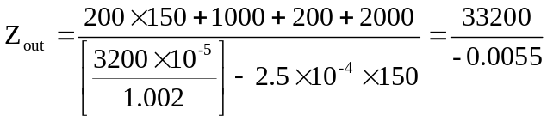
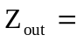–6.148 MΩ

